
W2 PRACTICE

Native HTTP and Manual Routing

At the end of this practice, you can
  - Create and run a native Node.js HTTP server
  - Manually implement route handling using conditionals.

  - Serve static files using fs.
  - Parse form data from POST requests.
  - Debug and enhance server code using console outputs.

 Get ready before this practice!
  - Read the following documents to understand Nodejs built-in HTTP module: https://nodejs.org/api/http.html
  - Read the following documents to understand Anatomy of an HTTP Transaction: https://nodejs.org/en/learn/modules/anatomy-of-an-http-transaction

 How to submit this practice?
    - Once finished, push your code to GITHUB
    - Join the URL of your GITHUB repository on LMS

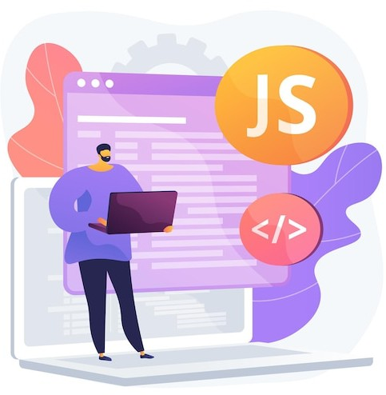

Goal: Learn how to initialize a server and verify it's alive.
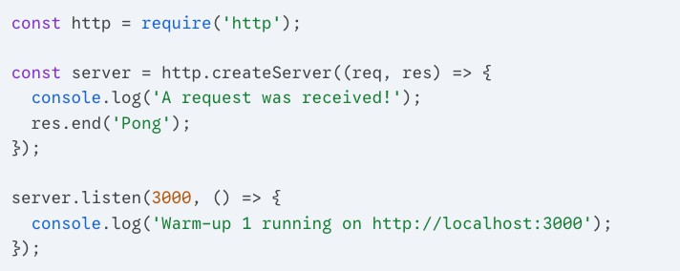

Task:

- Run the code.
- Open your browser to http://localhost:3000.

Lab2.2 The Modern Toolkit (Apidog Setup)
Goal: Install Apidog and use it to "talk" to your Node.js server. This replaces the need for using just the browser or complex curl commands.

Task 1: Installation
- Download: Go to apidog.com/download and download the desktop client for your OS (Windows, Mac, or Linux).
  - Tip: While there is a web version, the Desktop Client is better for beginners because it can easily access localhost without extra browser security headaches.
- Open & Guest Mode: You don't necessarily need an account to start. You can use it as a "Guest" or sign up to save your progress.

Task 2: The First Handshake
- Run your server: Use the code from Warm-Up 1 (the "Ping" server).

Create a Request in Apidog:
  - Click the "+" button to create a new tab.
  - Set the method to GET.
  - Enter the URL: http://localhost:3000.
  - Click Send.
- Inspect: Look at the Body tab in the response section at the bottom. Does it say "Pong"?

Goal: Understand that every request carries information about where it came from.
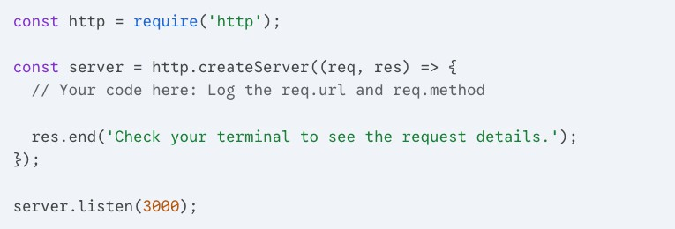

Task:

- Inside the function, use console.log() to print req.url and req.method.
- Visit http://localhost:3000/hello-world.
- Observe the terminal. What does the req.url show?

Lab2.4 Setting the Vibe (Status Codes)
Goal: Learn how to tell the browser if the request was successful or not using HTTP status codes.
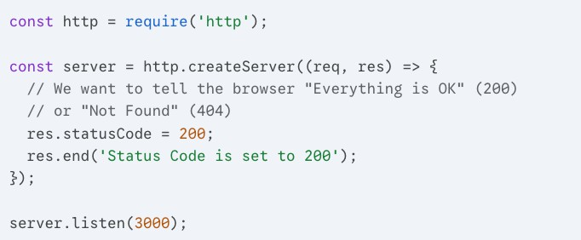

Task:

- Change the res.statusCode to 404.
- Refresh your browser.
- Open the Browser Developer Tools (F12) -> Network Tab. Refresh again and click on the "localhost" request. What color is the status code?

Goal: Use headers to tell the browser how to interpret the data you send.
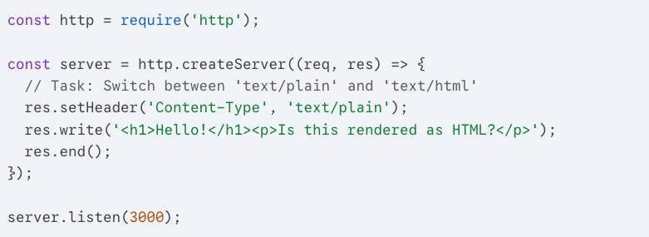

Task:

- Run the code as-is. Does the browser show the <h1> tags or a big heading?
- Change 'text/plain' to 'text/html'.
- Refresh the browser and observe the difference.

Lab2.6 The Live Clock (Dynamic Content)
Goal: Realize that Node.js can execute logic before sending the response.
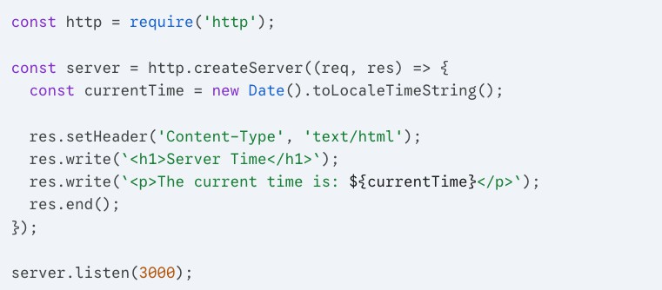

Task:

- Run the server and visit the page.
- Refresh the page 5 seconds later.
- Reflect: Why does the time change even though you didn't change the code? This is the power of a dynamic server vs. a static HTML file!

- Identify and fix the bug.
- Understand the request-response cycle in Node.js using the http module.
- Explain the role of res.write() and res.end() in sending data back to the client.

 For this exercise, you are provided with a minimal server.js file. Read and run the code and observe how it behaves.

// server.js
const http = require('http');

const server = http.createServer((req, res) => { res.write('Hello, World!');
return res.endd();
});

server.listen(3000, () => {
console.log('Server running on http://localhost:3000');
});

Q1 – What error message do you see in the terminal when you access
http://localhost:3000? What line of code causes it?

Q2 – What is the purpose of res.write() and how is it different from res.end()?

Q3 – What do you think will happen if res.end() is not called at all?

Q4 – Why do we use http.createServer() instead of just calling a function directly?

Q5 – How can the server be made more resilient to such errors during development?

- Practice using req.url and req.method.
- Understand how manual routing mimics what frameworks (like Express) automate.
- Serve both plain text and raw HTML manually.

  - For this exercise you will start with a START CODE (EX-2)

TASK 1 - Update the code above to add custom responses for these routes:

ROUTE | HTTP METHOD | RESPONSE
/about | GET | About us: at CADT, we love node.js!
/contact-us | GET | You can reach us vai email…
/products | GET | Buy one get one…
/projects | GET | Here are our awesome projects

Use VS Code’s Thunder Client (or other tools (POSTMAN, INSOMIA) of your choice or curl on your terminal to make request.
Example output

curl http://localhost:3000/about >
About us: at CADT, we love node.js!
curl http://localhost:3000/contact-us -------------------------
-> You can reach us vai email…

TASK 2 – As we can see the complexitiy grow as we add more routes. Use switch statement to arrange the code into more organized structure.

 Reflective Questions
- What happens when you visit a URL that doesn’t match any of the three defined?
The default case in the switch statement runs and sends back:
- 404 Not Found
Try it yourself — visit http://localhost:3000/random and you'll see it. This is important because without a default case, the server would just hang and never respond to the browser.

- Why do we check both the req.url and req.method?
- What MIME type (Content-Type) do you set when returning HTML instead of plain text?
- How might this routing logic become harder to manage as routes grow?
- What benefits might a framework offer to simplify this logic?

- Practice handling POST requests.
- Parse URL-encoded form data manually.
- Write and append to local files using Node.js' fs module.
- Handle async operations and errors gracefully.

  - For this exercise you will start with a START CODE EX-3

TASK 1 - Extend your Node.js HTTP server to handle a POST request submitted from the contact form. When a user submits their name, the server should:
- Capture the form data (from the request body).

Log it to the console.
- Write it to a local file named submissions.txt.
Testing, go to /contact on broswer and test

Requirements
  - Handle POST /contact requests.
  - Parse raw application/x-www-form-urlencoded data from the request body.
  - Write the name to a new line in submissions.txt.
  - Send a success response to the client (HTML or plain text).

Discussion Questions
- Why do we listen for data and end events when handling POST?
- What would happen if we didn’t buffer the body correctly?
- What is the format of form submissions when using the default browser form POST?
- Why do we use fs.appendFile instead of fs.writeFile?
- How could this be improved or made more secure?

Bonus Challenge (Optional)
  - Validate that the name field is not empty before saving.
  - Send back a small confirmation HTML page instead of plain text.
  - Try saving submissions in JSON format instead of plain text.

